Title of the abstract for the International Conference on Architecture and Environment 2025

First-name A. Last-name¹, First-name B. Last-name¹, First-name C. Last-name²
¹Address of the first Institution, e.g. Department or Division, University or Institute, Street 123, City, Country.
²Address of the Second Institution, e.g. Department or Division, University or Institute, Street 123, City, Country.
Email: presenting.author@institute.com

The main text, Times New Roman, Font size: 12, Regular. Paragraphs are justified (straight-edged) on both left and right. Do not change the page and margin dimensions, which is A4 and 2.4 cm on each side. Examples of reference formatting are provided below. There is no character limit for the main text, but the overall length of the abstract document must be limited to ONE PAGE, including an optional figure.
If you wish to include a figure in your abstract, replace the placeholder figure and caption with your own, otherwise remove them. Only one figure is allowed, in TIFF, JPEG, or PNG format (a file with sufficient resolution/quality for printing should be used). The size and position of your figure may be adjusted in the published material (printed in grayscale!).
Abstracts that do not follow these formatting requirements will be returned. The organizing committee reserves the right to edit abstracts for correct formatting.
REPLACE THIS TEXT WITH YOUR ABSTRACT.

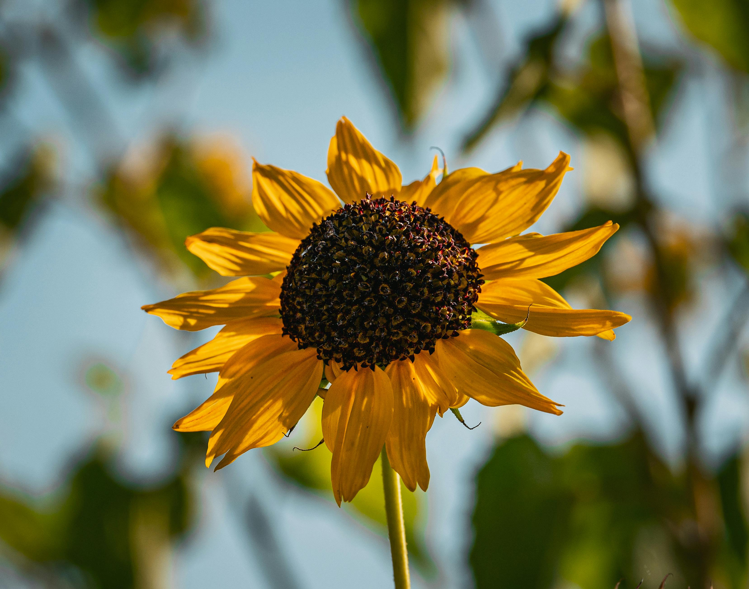
Fig1. Figure caption

Keywords: keyword1, keyword 2, …

[1] J. C. Overley, P. D. Parker, D. A. Bromley; The energy calibration of tandem accelerators; Nuclear Instruments and Methods, 1969 (example of journal article reference)
[2] …

